Load-Balancing Clusters
# Source: AI Source: Provided by: [Data Path: Persons Table -> ID Column: 1, Name_En Column: Motasem Essam] -> From: [ChatGPT] on [1/16/2026]
A Load-Balancing Cluster is a type of cluster system designed to distribute incoming requests evenly across multiple servers (nodes) to ensure high performance, reliability, and responsiveness.
It is commonly used for web servers, application servers, and network services where many clients make simultaneous requests.

Definition
# Source: AI Source: Provided by: [Data Path: Persons Table -> ID Column: 1, Name_En Column: Motasem Essam] -> From: [ChatGPT] on [1/16/2026]
A Load-Balancing Cluster:
- Distributes client requests among multiple nodes
- Prevents any single server from being overloaded
- Appears as a single system to users

Architecture Diagram
# Source: AI Source: Provided by: [Data Path: Persons Table -> ID Column: 1, Name_En Column: Motasem Essam] -> From: [ChatGPT] on [1/16/2026]
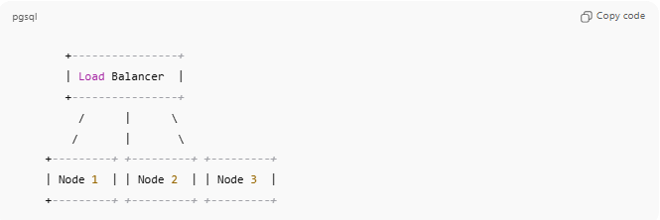
+----------------+
| Load Balancer |
+----------------+
/ | \
/ | \
+---------+ +---------+ +---------+
| Node 1 | | Node 2 | | Node 3 |
+---------+ +---------+ +---------+
- Load Balancer: Directs requests to the least busy or fastest node
- Nodes: Process requests and return results to clients

How It Works
# Source: AI Source: Provided by: [Data Path: Persons Table -> ID Column: 1, Name_En Column: Motasem Essam] -> From: [ChatGPT] on [1/16/2026]
- Client sends a request to the load balancer
- Load balancer decides which node should handle the request
- Node processes the request and returns the response
- Load is distributed evenly across all nodes

Key Characteristics
# Source: AI Source: Provided by: [Data Path: Persons Table -> ID Column: 1, Name_En Column: Motasem Essam] -> From: [ChatGPT] on [1/16/2026]
- Evenly distributes workload
- Improves system performance and response time
- Provides fault tolerance (if one node fails, others handle requests)
- Nodes can be added or removed without affecting service

Applications
# Source: AI Source: Provided by: [Data Path: Persons Table -> ID Column: 1, Name_En Column: Motasem Essam] -> From: [ChatGPT] on [1/16/2026]
- Web server farms (e.g., Google, Amazon, Facebook)
- E-commerce websites
- Online gaming servers
- Cloud applications with high traffic

Advantages
# Source: AI Source: Provided by: [Data Path: Persons Table -> ID Column: 1, Name_En Column: Motasem Essam] -> From: [ChatGPT] on [1/16/2026]
- Prevents server overload
- Ensures high availability and reliability
- Scalable (new nodes can be added easily)
- Can improve response time and performance

Disadvantages
# Source: AI Source: Provided by: [Data Path: Persons Table -> ID Column: 1, Name_En Column: Motasem Essam] -> From: [ChatGPT] on [1/16/2026]
- Requires additional hardware/software (load balancer)
- Load balancer can become a single point of failure if not redundant
- Configuration and maintenance can be complex

Simple Analogy
# Source: AI Source: Provided by: [Data Path: Persons Table -> ID Column: 1, Name_En Column: Motasem Essam] -> From: [ChatGPT] on [1/16/2026]
- Load-Balancing Cluster: Multiple cashiers at a supermarket, with a manager directing customers to the least busy cashier
- Ensures that no cashier is overloaded, and customers are served quickly

